The UI design

I design the simple_calculator on Android Studio

The design file is simple_calculator.zip

It's layout as follows

left : the panel on computer. right: the panel on android phone

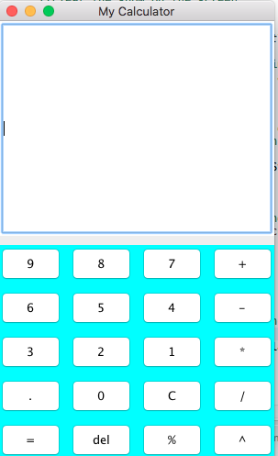

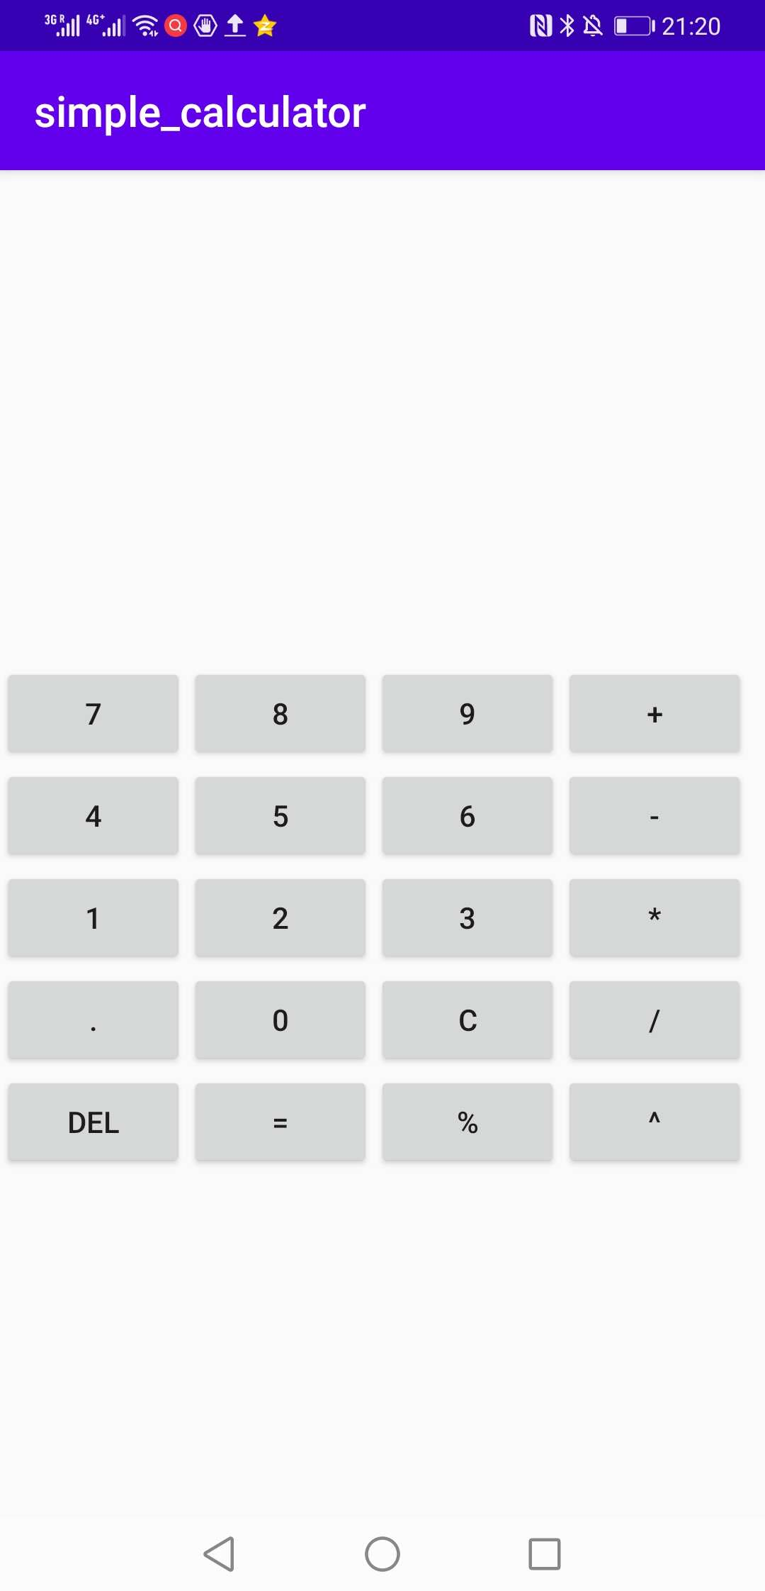

l

Both contains one textField and 20 function keys:

11 keys of which are the number keys(include the decimal key);

6 keys of which are operators ;

3 keys of which are function keys(backspace,clear and equal key)

I take the graph components as follows.

